COMSATS University Islamabad

Attock Campus



MAD

AHMED IKRAM RAO

(sp22-bse-049)

10 DEC, 2024

APP.js
import React from 'react';
import { NavigationContainer } from '@react-navigation/native';
import { createStackNavigator } from '@react-navigation/stack';
import SignupScreen from './screens/SignupScreen';
import LoginScreen from './screens/LoginScreen';
import ThirdScreen from './screens/ThirdScreen'; // Screen from Assignment 2

const Stack = createStackNavigator();

export default function App() {
return (
<NavigationContainer>
<Stack.Navigator initialRouteName="Signup">
<Stack.Screen name="Signup" component={SignupScreen} />
<Stack.Screen name="Login" component={LoginScreen} />
<Stack.Screen name="ThirdScreen" component={ThirdScreen} />
</Stack.Navigator>
</NavigationContainer>
);
}

Signuup
import React, { useState } from 'react';
import { View, TextInput, Button, Text, StyleSheet } from 'react-native';

export default function SignupScreen({ navigation }) {
const [username, setUsername] = useState('');
const [email, setEmail] = useState('');
const [password, setPassword] = useState('');
const [phone, setPhone] = useState('');

const validateForm = () => {
const emailRegex = /^[^\s@]+@[^\s@]+\.[^\s@]+$/;
const phoneRegex = /^\+92-3\d{2}-\d{7}$/;
if (!username.match(/^[A-Za-z]+$/)) return alert('Username must contain alphabets only.');
if (!emailRegex.test(email)) return alert('Invalid email format.');
if (password.length < 8) return alert('Password must be at least 8 characters.');
if (!phoneRegex.test(phone)) return alert('Phone number must match +92-3xx-xxxxxxx format.');
navigation.navigate('Login');
};

return (
<View style={styles.container}>
<Text>Signup</Text>
<TextInput placeholder="Username" value={username} onChangeText={setUsername} style={styles.input} />
<TextInput placeholder="Email" value={email} onChangeText={setEmail} style={styles.input} keyboardType="email-address" />
<TextInput placeholder="Password" value={password} onChangeText={setPassword} style={styles.input} secureTextEntry />
<TextInput placeholder="Phone" value={phone} onChangeText={setPhone} style={styles.input} keyboardType="phone-pad" />
<Button title="Signup" onPress={validateForm} />
</View>
);
}

const styles = StyleSheet.create({
container: { flex: 1, justifyContent: 'center', padding: 20 },
input: { borderWidth: 1, padding: 10, marginVertical: 10 },
});

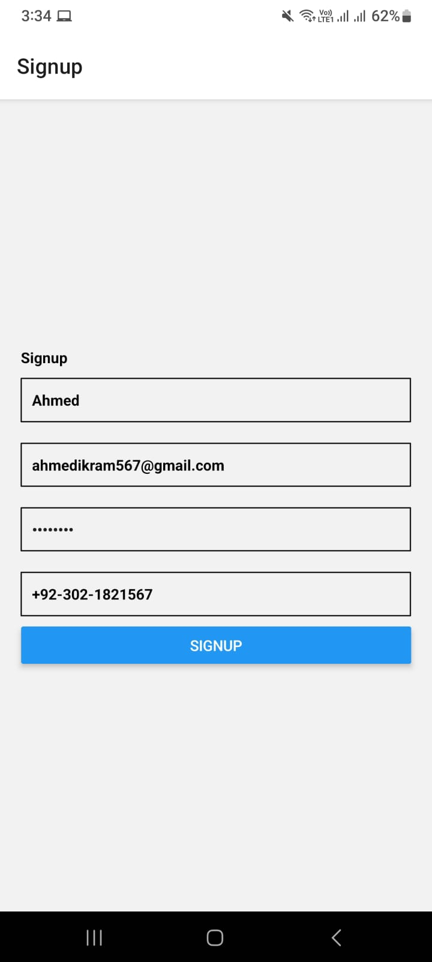
Login.js
import React, { useState } from 'react';
import { View, TextInput, Button, Text, StyleSheet } from 'react-native';

export default function LoginScreen({ navigation }) {
const [email, setEmail] = useState('');
const [password, setPassword] = useState('');

const handleLogin = () => {
if (!email || !password) return alert('All fields are required.');
navigation.navigate('ThirdScreen');
};

return (
<View style={styles.container}>
<Text>Login</Text>
<TextInput placeholder="Email" value={email} onChangeText={setEmail} style={styles.input} keyboardType="email-address" />
<TextInput placeholder="Password" value={password} onChangeText={setPassword} style={styles.input} secureTextEntry />
<Button title="Login" onPress={handleLogin} />
</View>
);
}

const styles = StyleSheet.create({
container: { flex: 1, justifyContent: 'center', padding: 20 },
input: { borderWidth: 1, padding: 10, marginVertical: 10 },
});

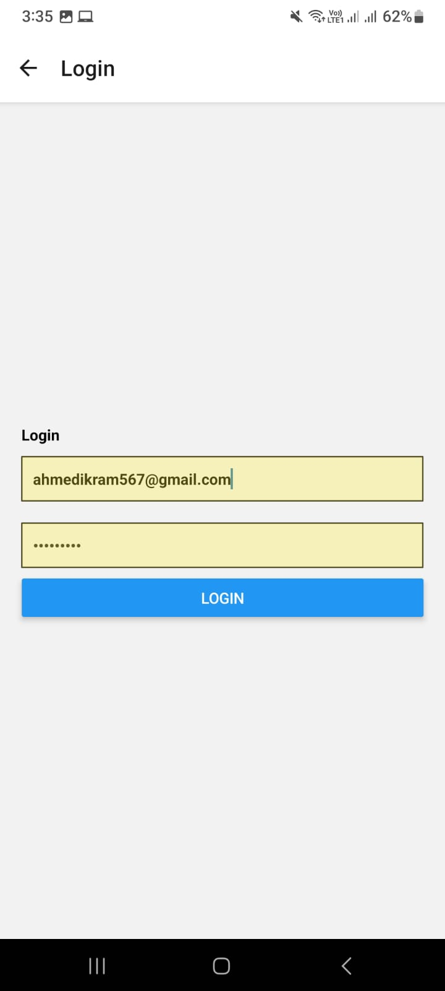
Third.js
import React from 'react';
import { View, Text, Image, StyleSheet, ScrollView } from 'react-native';

const ProfileScreen = () => {
return (
<ScrollView style={styles.container}>
{/* Profile Header */}
<View style={styles.profileHeader}>
<Text style={styles.profileTitle}>My Profile</Text>
<Image
source={{ uri: 'https://img.icons8.com/ios-filled/50/ffffff/settings.png' }}
style={styles.settingsIcon}
/>
</View>

{/* User Info */}
<View style={styles.userInfo}>
<Text style={styles.userName}>AHMED IKRAM RAO</Text>
<View style={styles.userStats}>
<View style={styles.statBox}>
<Text style={styles.statValue}>14.850</Text>
<Text style={styles.statLabel}>Product Sells</Text>
</View>
<View style={styles.statBox}>
<Text style={styles.statValue}>30bil+</Text>
<Text style={styles.statLabel}>Earning</Text>
</View>
</View>
</View>

{/* Recent Orders */}
<Text style={styles.recentOrdersTitle}>Recent Orders</Text>
<View style={styles.orderList}>
{orderData.map((order, index) => (
<View key={index} style={styles.orderCard}>
<Image source={{ uri: order.image }} style={styles.orderImage} />
<View style={styles.orderDetails}>
<Text style={styles.orderTitle}>{order.title}</Text>
<Text style={styles.orderDate}>{order.date}</Text>
</View>
<Text style={styles.orderPrice}>{order.price}</Text>
</View>
))}
</View>
</ScrollView>
);
};

// Sample data for orders
const orderData = [
{
image: 'https://encrypted-tbn0.gstatic.com/images?q=tbn:ANd9GcRJV1RVOmJGwrWjio1p4M40W-ijLmZiVS0Swg&s',
title: 'French Fries',
date: '21, Thu 10:00',
price: '$38.15',
},
{
image: 'https://encrypted-tbn0.gstatic.com/images?q=tbn:ANd9GcRFkrQJD5kWtJmYQjURG_zlDC_GqWLMSAzsSA&s',
title: 'Icecream',
date: '15, Fri 18:00',
price: '$38.15',
},
{
image: 'https://encrypted-tbn0.gstatic.com/images?q=tbn:ANd9GcT59siP2RQ0_tArSBYwc9qZeOP9ctZg67Hg1w&s',
title: 'Beef Burger',
date: '11, Mon 10:00',
price: '$30.50',
},
];

const styles = StyleSheet.create({
container: {
flex: 1,
backgroundColor: '#1E1E1E',
paddingHorizontal: 16,
},
profileHeader: {
flexDirection: 'row',
justifyContent: 'space-between',
marginVertical: 20,
},
profileTitle: {
fontSize: 26,
fontWeight: 'bold',
color: '#FFF',
},
settingsIcon: {
width: 30,
height: 30,
tintColor: '#FFF',
},
userInfo: {
backgroundColor: '#333',
borderRadius: 12,
padding: 20,
alignItems: 'center',
},
userName: {
fontSize: 20,
fontWeight: 'bold',
color: '#FFF',
},
userStats: {
flexDirection: 'row',
marginTop: 15,
justifyContent: 'space-between',
width: '100%',
},
statBox: {
alignItems: 'center',
flex: 1,
},
statValue: {
fontSize: 18,
fontWeight: 'bold',
color: '#FFC107',
},
statLabel: {
fontSize: 13,
color: '#AAA',
},
recentOrdersTitle: {
marginTop: 20,
fontSize: 22,
fontWeight: 'bold',
color: '#FFF',
},
orderList: {
marginTop: 10,
},
orderCard: {
flexDirection: 'row',
backgroundColor: '#292929',
borderRadius: 12,
padding: 15,
marginVertical: 10,
alignItems: 'center',
justifyContent: 'space-between',
},
orderImage: {
width: 50,
height: 50,
borderRadius: 8,
},
orderDetails: {
flex: 1,
marginLeft: 10,
},
orderTitle: {
fontSize: 16,
fontWeight: 'bold',
color: '#FFF',
},
orderDate: {
fontSize: 12,
color: '#AAA',
},
orderPrice: {
fontSize: 16,
fontWeight: 'bold',
color: '#FFC107',
},
});

export default ProfileScreen;

